

Heating Manual 2026

T3521, T3521X or T3521S

HeatingSave™ 589 Great North Road, St Neots, Cambridgeshire, PE19 7GJ
Tel: 01480 223923.
All content © 2021 HeatingSave.
Table Of Contents
HeatingSave Overview 1
How does it work? 1
How to control HeatingSave 1
Logging Into HeatingSave 2
remote.heatingsave.com 2
Local Network 2
Logging into HeatingSave 2
The HeatingSave software 3
Overview 4
Boiler Information 4
Zone Information 4
Shortcuts 5
Heating diary and patterns 6
Heating Patterns 6
Pattern Options 6
Heating Diary 7
Default Diary 7
Exceptions Diary 7
T3520 Keypad Operation 9
Keypad functions 9
Boost 9
Ignore 9
Raise/Lower Setpoint 10
Relay Test Menu 10
Altering the network settings 11
Notes 12

HeatingSave Overview

HeatingSave is a smart building management system capable of more efficiently running any building and cutting costs while maintaining a comfortable level of heating.

How does it work?

At the heart of HeatingSave is a state-of-the-art microprocessor connected to several temperature sensors measuring external, room and boiler temperatures.

The T3520 controller has 8 temperature inputs, 8 occupancy/switch inputs and 8 mains relay outputs, with each relay capable of switching mains (10amps max.) or distributing mains (5 amps max.)

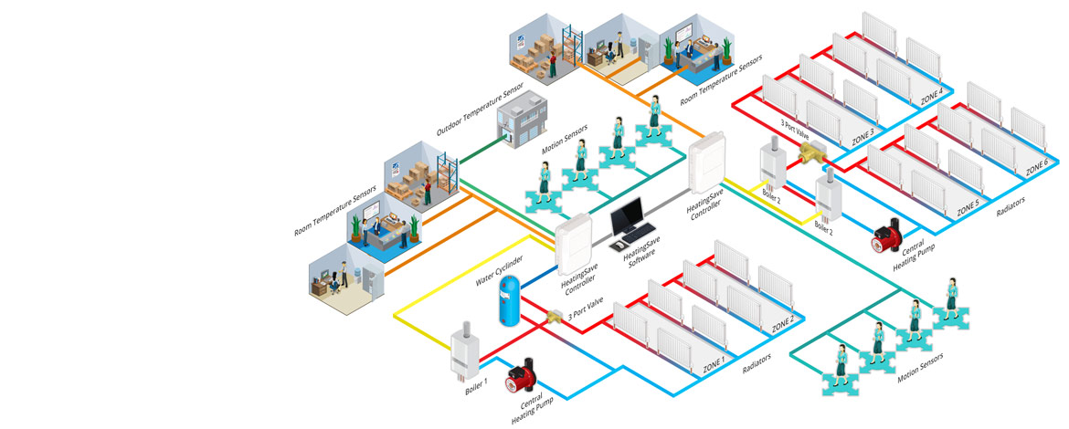

How to control HeatingSave

The HeatingSave software is web-based. Using a web browser on a desktop PC, laptop or tablet you can edit and control your HeatingSave system.

Using https://remote.heatingsave.com you are able to connect to your HeatingSave system using your HS number from anywhere in the world provided you have an internet connection.

Logging Into HeatingSave

remote.heatingsave.com

You can access your HeatingSave system from any compute with an internet connection and web browser. On the back of the HeatingSave hub (Product number T3521 or T3521X) is a white sticker with the SSID. For example if the sticker has “SSID: hs123456” your HS number would be 123456.

With your HS number you now navigate to https://remote.heatigsave.com in your web browser and when prompted enter your HS number.

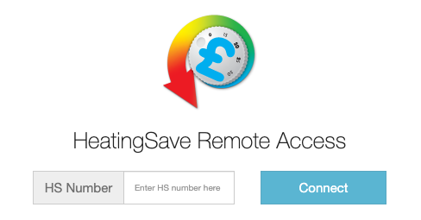

Local Network

If you know the IP address of your HeatingSave system and you are on the same network as the HeatingSave Hub you can navigate to the HeatingSave software by typing in the IP address in you web browser (i.e. 192.168.0.30).

Logging into HeatingSave

Once you have connected to your HeatingSave system you will be prompted with a login form. Just enter in your Login ID and password and click on the Login button. If you need assistance from HeatingSave support, click the support link and pass the information onto the technician. This will give them access to your system remotely without giving out any passwords.

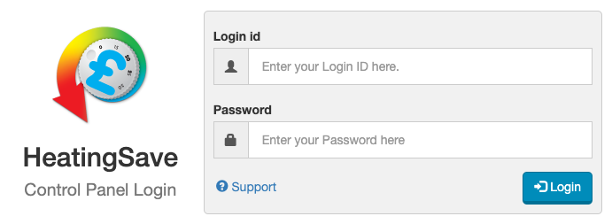

The HeatingSave software

Once you have logged into your HeatingSave system the software will load. To the left of the screen will be the tree menu, this will display all your HeatingSave controllers (Product number T3520). If you want to select a different controller just select it in the menu and the page will reload. If you have multiple controllers, you can select multiple if you hold down the shift key.

Along the top of the screen is the main navigation bar, to access other areas of the software you just hover over menu item, and it will expand showing the sub menu items.

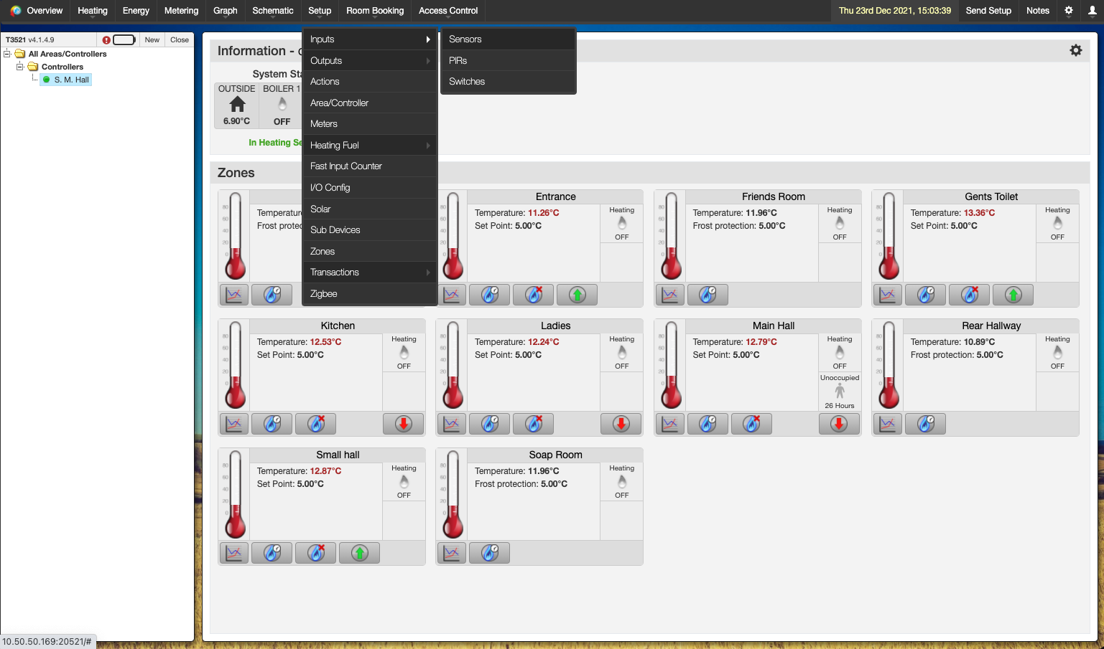

Overview

The HeatingSave overview gives you detailed information about the current status of the heating system. The overview can be found to the left hand of the top navigation bar.

Boiler Information

At the top of the page, you will see information regarding the boilers within your heating system as well as external factors effecting it.

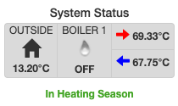

The first tile shows the outside temperature, this is used by the algorithm to calculate the correct time to start heating a zone.

The middle tile shows if the boiler is currently on or off, if the boiler of on the icon will show a blue flame. If you have multiple boilers each boiler will be displayed here in a separate tile.

The end tile shows the current boiler flow temperature (top value) along with the boiler return temperature (bottom value).

Underneath the tiles will display if the HeatingSave system is in winter or summer mode. If the boiler is in winter mode it will display “In Heating Season”.

Zone Information

Under the boiler information is a list of all your heating zones on the controllers you have selected within the tree menu. Each zone has its own tile containing information regarding that zone.

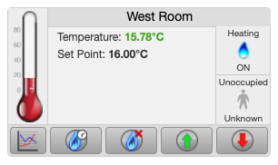

Within the tile you can see the current temperature within the zone along with set point that the zone is maintaining.

To the right of the tile, you can see if the zone is currently heating. If the heating zone also has PIR sensors you can also see if its occupied or not.
Along the bottom of the tile there are several buttons that you can use to alter the status of the zone heating:

- Graph - If you want to see historic information regarding the heating status of this zone click this button. Once clicked the graph will be loaded along with any device associated with this zone.
- Boost – If you want a short burst of heat within this zone click this button. Once clicked the setpoint will be increased for the duration set for this zone. To cancel the boost just click the button again and the heating will resume as normal.
- Ignore – If you want to cancel the heating within this zone just click on the ignore button and the heating will be stopped until the next heating period. To resume the heating just click the button again and the heating will resume as normal.
- Raise – Using the raise button will increase the set point of the zone by 0.5°C until the next heating period.
- Lower – Using the lower button will decrease the set point of the zone by 0.5°C until the next heating period.

Shortcuts

Each zone tile has shortcuts to different devices within the zone.

- If you click on the thermomotor any sensors used to control the temperature within that zone will be displayed.
- If you click on the zone title the “Edit Zone” popup will appear where you can edit the heating zone.
- If you click on the occupancy status, any PIR associated with the heating zone will be displayed.

Heating diary and patterns

Each heating zone within HeatingSave has a heating diary and a default heating pattern for each day of the week. A standard pattern can be entered for each day and exceptions only created as they occur.

Heating Patterns

To view a list of all patterns that have been programmed within your system hover over the Heating item to the left of the top navigation bar and click on Patterns.

Within a heating pattern you can set different temperatures for a heating zone at any interval during the day.

Each pattern is given a description and an abbreviation these are displayed on the web software and controller keypad.

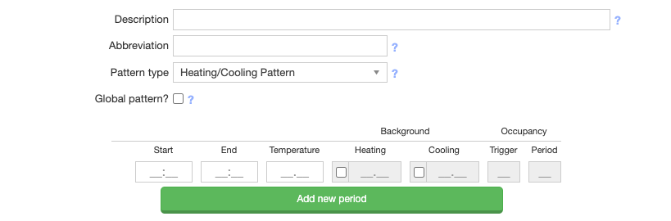

A pattern can be setup to be used globally within the software, this means that any controller within your HeatingSave system

Pattern Options

- Start – This is the start time of the heating period, if you have a period that ends at 10:00 the period can start at 10:01 at the soonest.
- End – This is the end time of the heating period.
- Temperature – This is the target temperature that the zone will maintain between the start and end times.
- Background Heating – This is the temperature that the zone will heat to when the zone is unoccupied, when the zone is occupied the temperature will raise up to the “Temperature” set point
- Background Cooling – This is the temperature that the zone will cool to when the zone is unoccupied, when the zone is occupied the temperature will lower down to the “Temperature” set point
- Occupancy Trigger – This is how many times a PIR needs to be triggered for the zone to deactivate background heating or background cooling.
- Occupancy Period – Once the occupancy trigger threshold has been exceeded the pattern will be altered for the number of minutes defined here.

Heating Diary

To view the heating diary hover over the Heating item to the left of the top navigation bar and click on Diary.

Within the heating diary you can set default patterns for each weekday as well as pattern overrides for individual zones on specific days.

When on the diary you can select between the Heating Diary (defaults) and the Exceptions.

Default Diary

When the Heating Diary is selected you can modify multiple zones and days at the same time by clicking on a table cell and dragging your mouse to another cell. As you do this the table will highlight all the cells that you are about to edit. Once you release the mouse click a modal will appear with a list of patterns that you can apply to the highlighted cells.

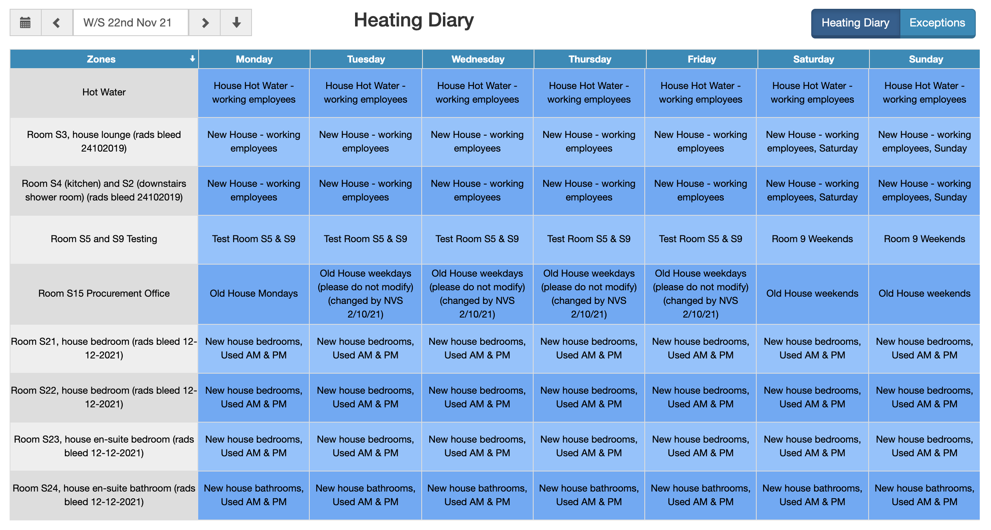

Exceptions Diary

When the Exceptions diary is selected you can modify it just like you would the default diary. To the top right of the diary is a date selection input, there you can select any date. Dates in the past have a grey background and can’t be edited. If there is an exception in place for a zone on a specific date the background is green with the name of the pattern in the cell.

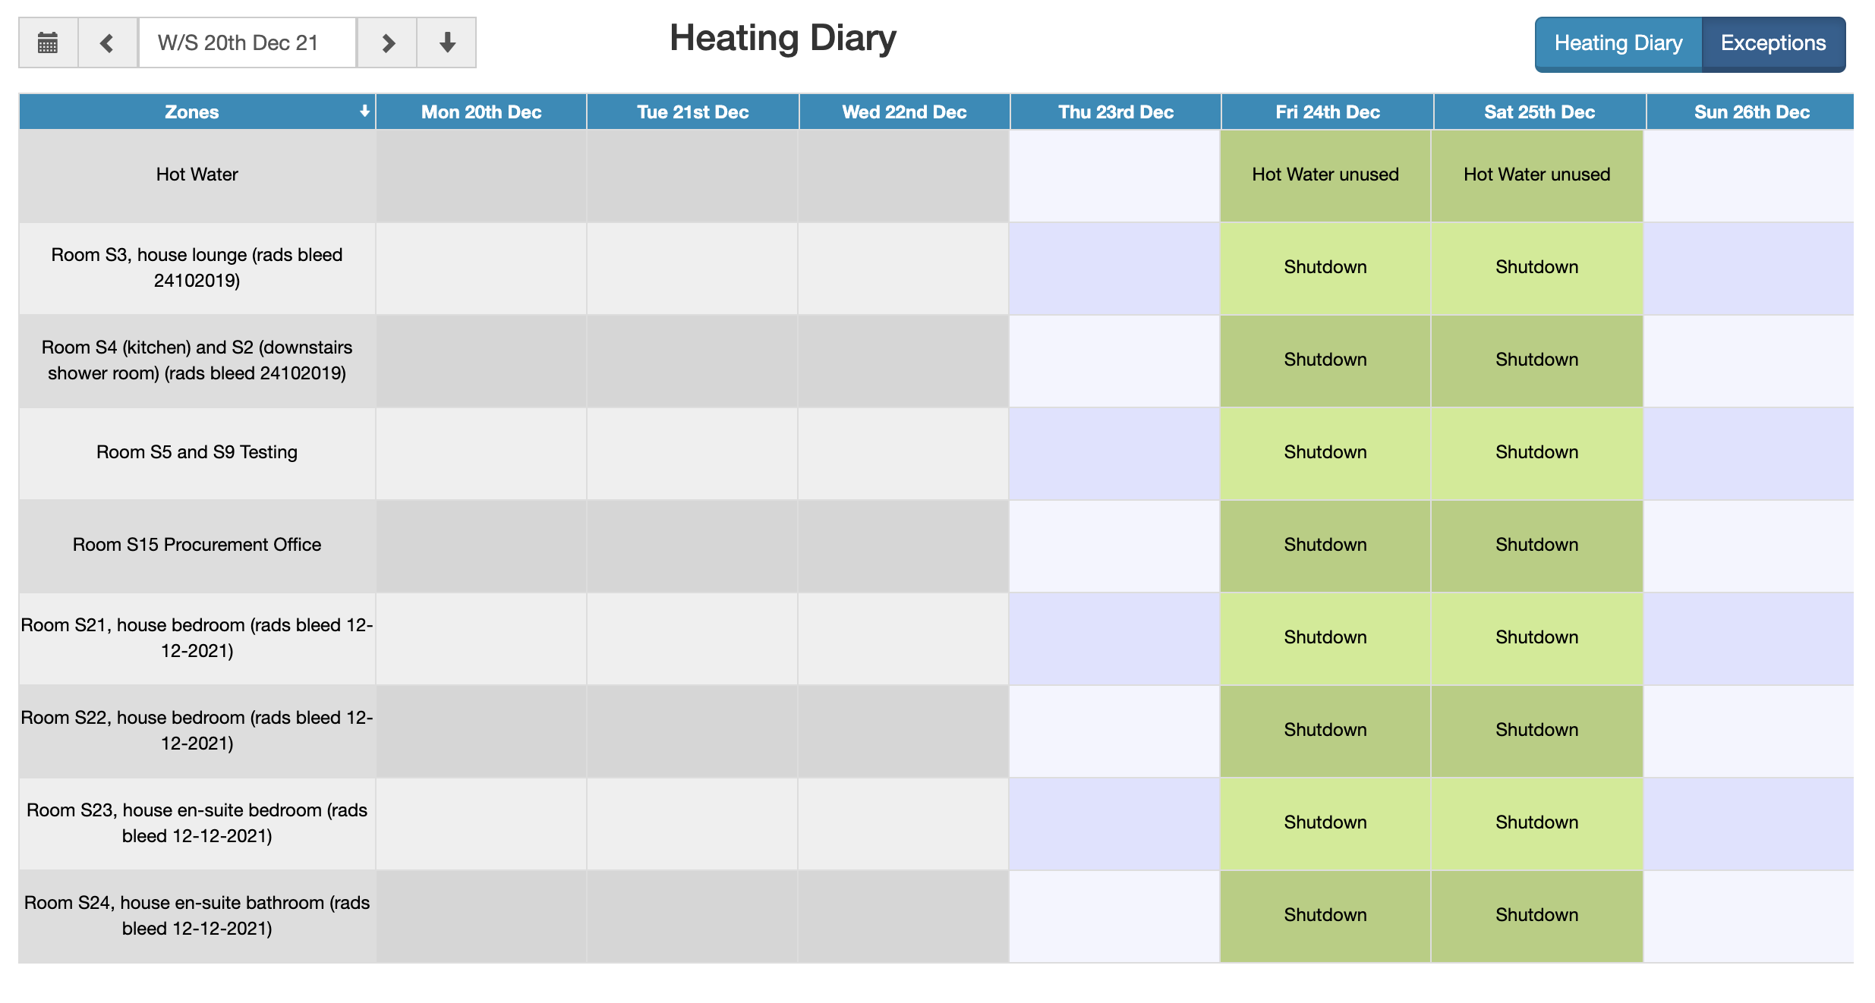

T3520 Keypad Operation

The keypad should only be used to diagnose the heating system and in the event of server failure.

The keypad attached on the T3520 controller is used to configure certain key parameters including network configuration to enable data transmission via the network between the main controller T3521 and the T3520 that includes the processor and relay board.

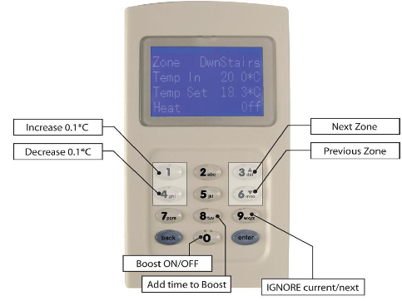
Keypad functions

Key 0 – Boost ON/OFF
Key 1 – Increase temperature by 0.5C
Key 2 – Unused
Key 3 – Scroll up/next zone
Key 4 – Decrease temperature by 0.5C
Key 5 – Unused
Key 6 – Scroll down/previous zone
Key 7 – Unused
Key 8 – Add time boost
Key 9 – Ignore current heating pattern
Back – Go back
Enter – Enter settings

Boost
From the home screen, use 3 or 6 to scroll to a zone, then hit the 0 key to start boost heating. The top line will say Zone +B. Boost allows heating outside of set patterns.

If the system is currently in a heating period, and the boost temperature is higher, hitting boost will override the current set temperature. The amount of time each zone boosts for can be changed in the zone settings.

Use the 8 key to ‘top up’ the boost timer. E.g. if the boost time in zone settings is set to 60 minutes, the 8 key will add 60 minutes to the timer with every key press. Hit 0 again to cancel.

Ignore
The ‘Ignore Current/Next Period’ function can be used to turn off the current heating period or to ignore the upcoming period. To use this feature, scroll to the desired zone with 3 or 6 then hit 9. To resume normal operation, hit the 9 key again.

When this function is used, the bottom line of the quick zone menu will display ‘Ignore’ and the number of minutes. This is the amount of time until the end of the period which is being ignored. For example, if a period ends at 18:00 and the ignore key is pressed at 17:30, the heating for that zone will be switched off and the screen will read ‘Ignore 30’.

Raise/Lower Setpoint

The raise and lower function can be used to alter the setpoint in 0.5°C increments.
Using the buttons 3 and 6 scroll to the zone that you want to alter. Use button 1 to increase the temperature and button 4 to decrease the temperature.

The new setpoint will remain until the next heating period is applied.

Relay Test Menu
The keypad contains a quick and easy method of turning on/off all the connected parts of the heating system:
1) Press 
If prompted enter the passcode (ask the owner) and hit enter again.
2) Scroll down to ‘Test’ using  then hit
Enter the setup passcode if prompted and hit enter again.
3) Scroll down to ‘Outputs’ using then hit
4) Scroll down to ‘Hardware’ using then hit
5) Turn the relays on/off using enter Using the points list above for reference.
Note - If the system had relays switched on at the time you entered the ‘Test ---> Relays’ menu, these will still be on, and shown as ‘ON’. These can be turned on or off for testing but will return to the state they were in when you leave the menu.
6) Exit the test menu using 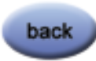
Note - The system will remain in the ‘test’ state until you hit back.

Altering the network settings

Using the keypad to change the controllers IP address follow the instructions below:

1) Press
If prompted enter the passcode (ask the owner) and hit enter again.

2) Scroll down to ‘Settings’ using then hit
Enter the setup passcode if prompted and hit enter again.
3) Scroll down to ‘Network Settings’ using then hit
4) Scroll down to ‘Unit ID’ using then hit
5) Using the keypad enter the unit ID as 3 digits then hit to save
Prefix the ID with 0’s as needed i.e. if the network ID is 52 you would enter 052 or if the network ID was 9 enter 009

6) Scroll down to ‘IP Address’ using then hit

7) Using the keypad, you can use the button to delete digits

8) Enter the IP Address as 12 digits then hit to save
You need to prefix each octet of numbers with 0’s i.e. if the IP address was 192.168.1.25 you would enter 192.168.001.025

9) Scroll down to ‘Subnet Mask’ using then hit

10) Using the keypad, you can use the button to delete digits

11) Enter the Subnet Mask as 12 digits then hit to save
You need to prefix each octet of numbers with 0’s i.e. if the IP address was 255.255.255.0 you would enter 255.255.255.000

12) Scroll down to ‘Gateway’ using then hit

13) Using the keypad, you can use the button to delete digits

14) Enter the Gateway Address as 12 digits then hit to save
You need to prefix each octet of numbers with 0’s i.e. if the IP address was 192.168.1.25 you would enter 192.168.001.025

15) Press button until you are back at the zone list

Notes
………………………………………………………………………………………………………………………………..………………………………………………………………………………………………..………………………………………………………………………………………………..………………………………………………………………………………………………..………………………………………………………………………………………………..………………………………………………………………………………………………..………………………………………………………………………………………………..………………………………………………………………………………………………..………………………………………………………………………………………………..…………………………………………………………………………………………………………..………………………………………………………………………………………………..………………………………………………………………………………………………..………………………………………………………………………………………………..…………………………………………………………………………………………………………..………………………………………………………………………………………………..………………………………………………………………………………………………..………………………………………………………………………………………………..…………………………………………………………………………………………………………..………………………………………………………………………………………………..…………………………………………………………………………………………………..………………………………………………………………………………………………..………………………………………………………………………………………………..…………………………………………………………………………………………………………..………………………………………………………………………………………………..…………………………………………………………………………………………………..………………………………………………………………………………………………..………………………………………………………………………………………………..…………………………………………………………………………………………………………..………………………………………………………………………………………………..…………………………………………………………………………………………………..………………………………………………………………………………………………..………………………………………………………………………………………………..…………………………………………………………………………………………

